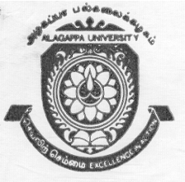 |  | ALAGAPPA UNIVERSITY  (Established by an Act of the Govt. of Tamil Nadu)  (Re-accredited with “A” Grade by NAAC)  KARAIKUDI – 630 003 |  | 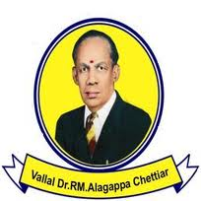
Walk-in Interview
Applications are invited from eligible candidates for temporary Teaching Assistants in the following disciplines at a consolidated remuneration of Rs.10,000/- per month for the academic year 2014-2015 or till the regular arrangement is made whichever is earlier. Interested candidates can attend the Walk-in Interview which will be held at 10.00 a.m. on 25.06.2014 in the administrative building of Alagappa University, Karaikudi.

Sl. No. | Department |  | No. of post(s)
1 | Economics and Rural Development |  | 3
2 | English and Foreign Languages |  | 1
3 | Computer Science and Engineering |  | 4
4 | Animal Health and Management |  | 3
5 | Bioinformatics |  | 2
6 | Library and Information Science |  | 2
7 | Alagappa Institute of Management |  | 2
8 | International Business and Commerce |  | 5
9 | Bank Management |  | 2
10 | Corporate Secretaryship |  | 1
No TA/DA will be paid for attending the walk-in interview.
Minimum Qualification required: PG Degree in relevant subject with at least 55% of Marks and M.Phil. in relevant discipline. However, preference will be given to the candidates with NET/SLET/SET and/or Ph.D.

Note: The M.Phil. and Ph.D. degrees obtained through the Correspondence/ Distance Education/Open University System are ineligible for the posts notified.

Interested eligible candidates may apply in the prescribed format which can be downloaded from the University website www.alagappauniversity.ac.in. At the time of walk-in interview, the candidates should bring all the original certificates along with the filled-in application format and attested copies of certificates. The University reserves the right to fill all or less number of posts at its discretion depending upon the requirements.

12.06.2014 REGISTRAR

